Experiment – 7: Data Visualization Using Tableau (
AIM:
To visualize and analyze COVID-19 data using Tableau by creating interactive dashboards consisting of various charts and graphs.
Dataset Used:
COVID-19 Dataset (Columns may include: Date, Country/Region, Confirmed Cases, Deaths, Recovered, Active Cases, New Cases, New Deaths, etc.)

PROCEDURE:
1) Importing Dataset into Tableau
Steps:
- Open Tableau Desktop / Tableau Public.
- On the Start Page, under Connect, click on the data source type:
→ Microsoft Excel / Text/CSV (depending on your file format).
- Browse and select your COVID-19 dataset.
- Click Open → then Sheet 1 to begin visualization.

2) Exploring the Data
- Check that Tableau correctly identifies field types:
  - Dimensions (blue): Country/Region, Province/State, Date, Continent, etc.
  - Measures (green): Confirmed Cases, Deaths, Recovered, Active Cases, New Cases, etc.
- Rename or change data types if necessary (e.g., convert Date column to Date type).

Step 1 : Importing Data as CSV files
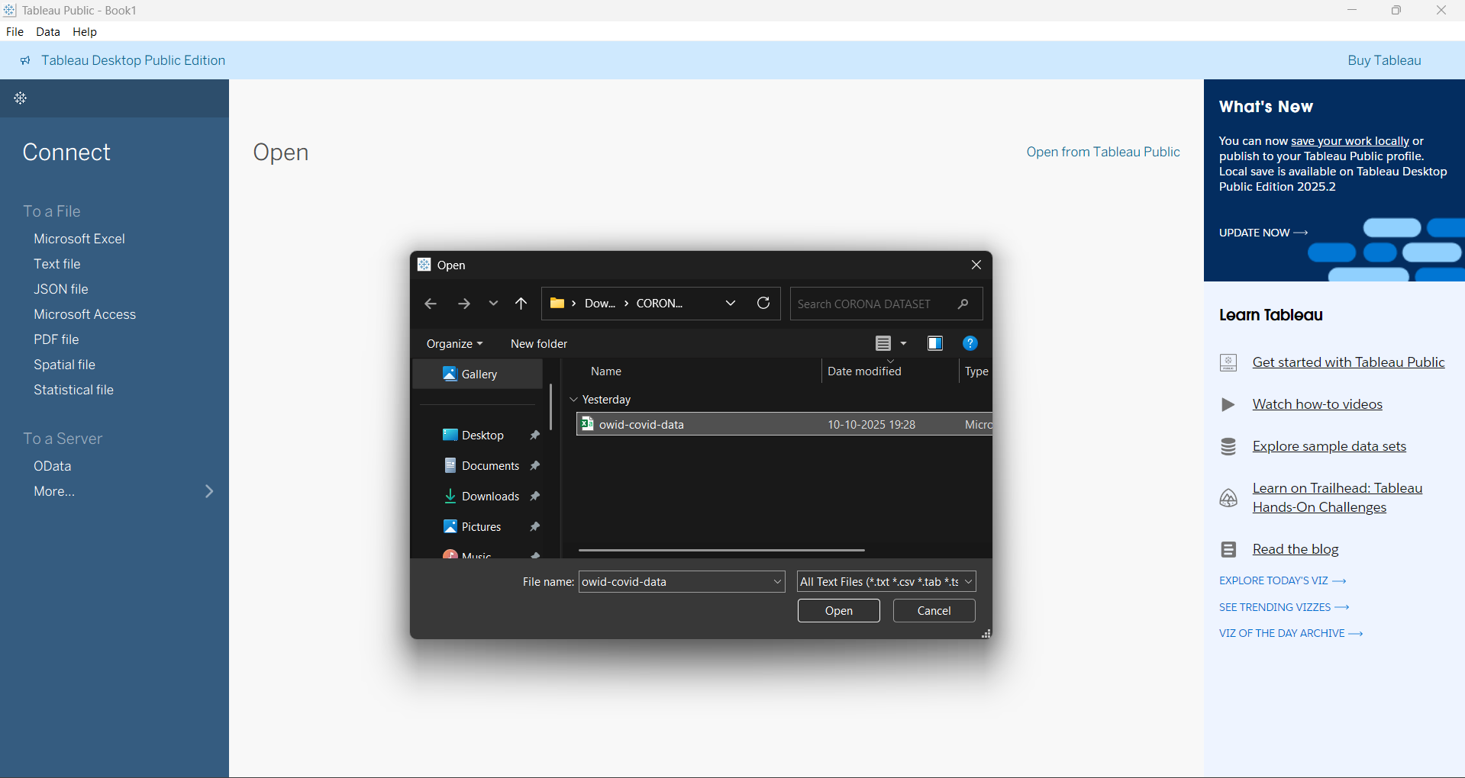

Step 2: First Page after uploading, now click on sheet 1 to open the visualization page

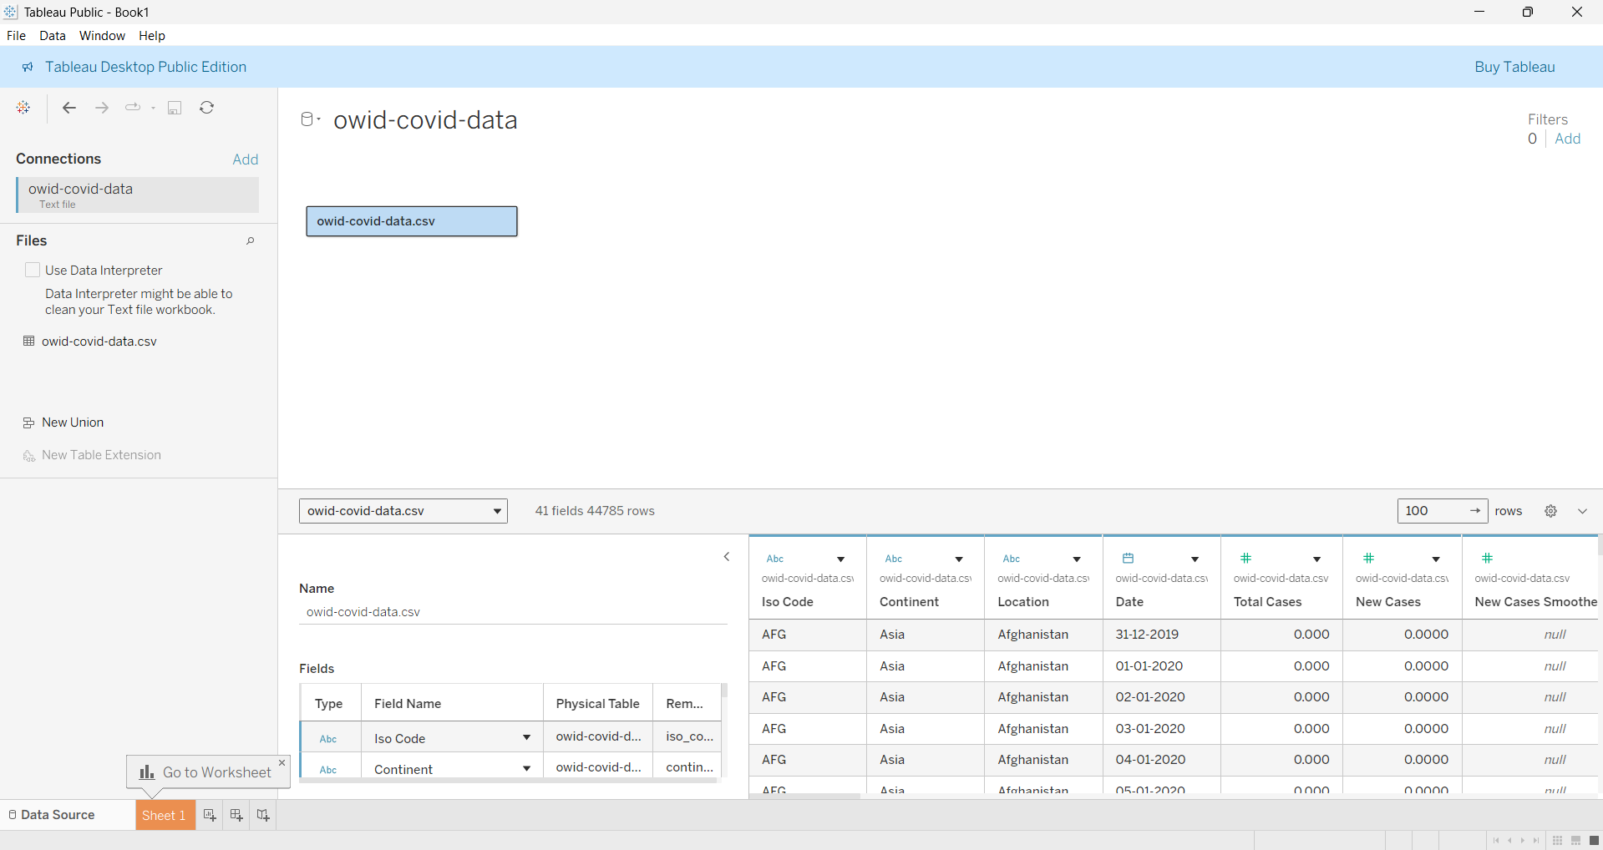

Step 3: This is the Visualization Page
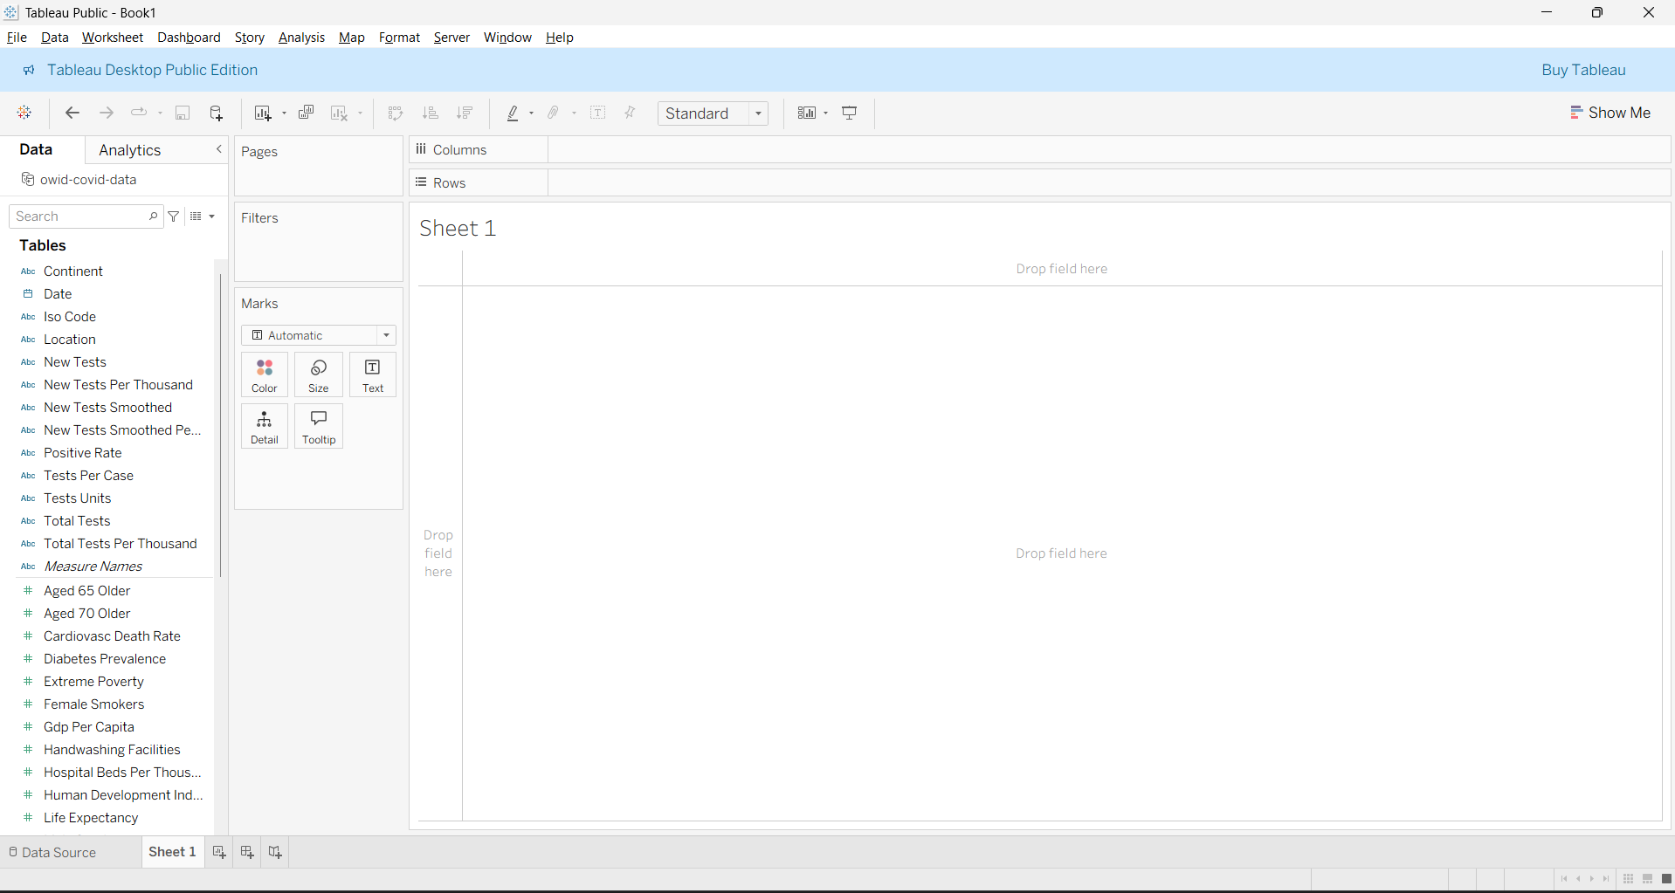

Types Of Graphs :

1 . Bar Graph(Side-by-Side Graph) :
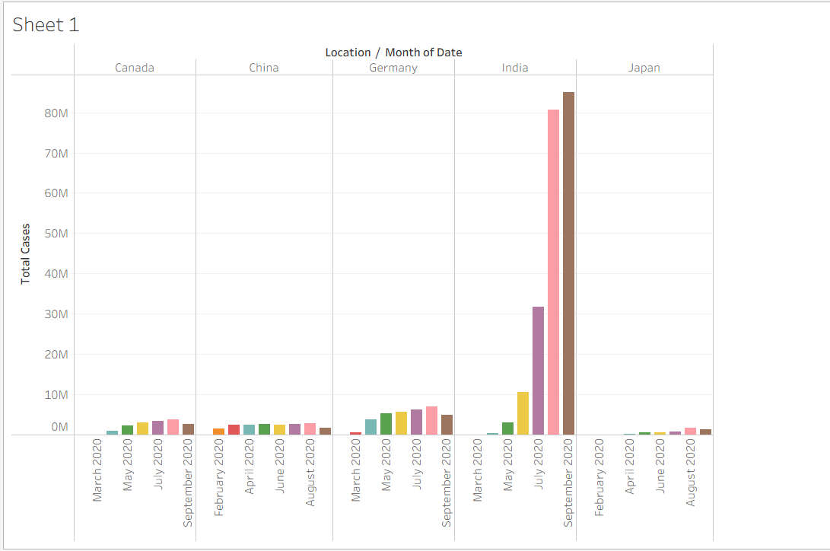

2.Line Graph :
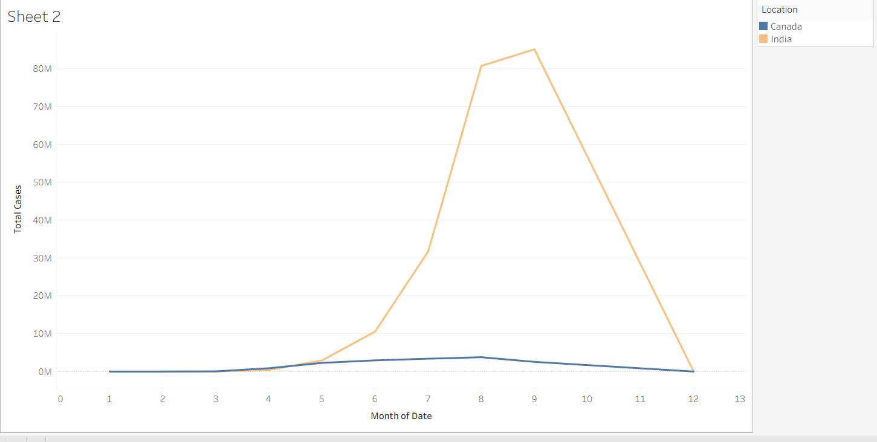

3. Pie Chart :
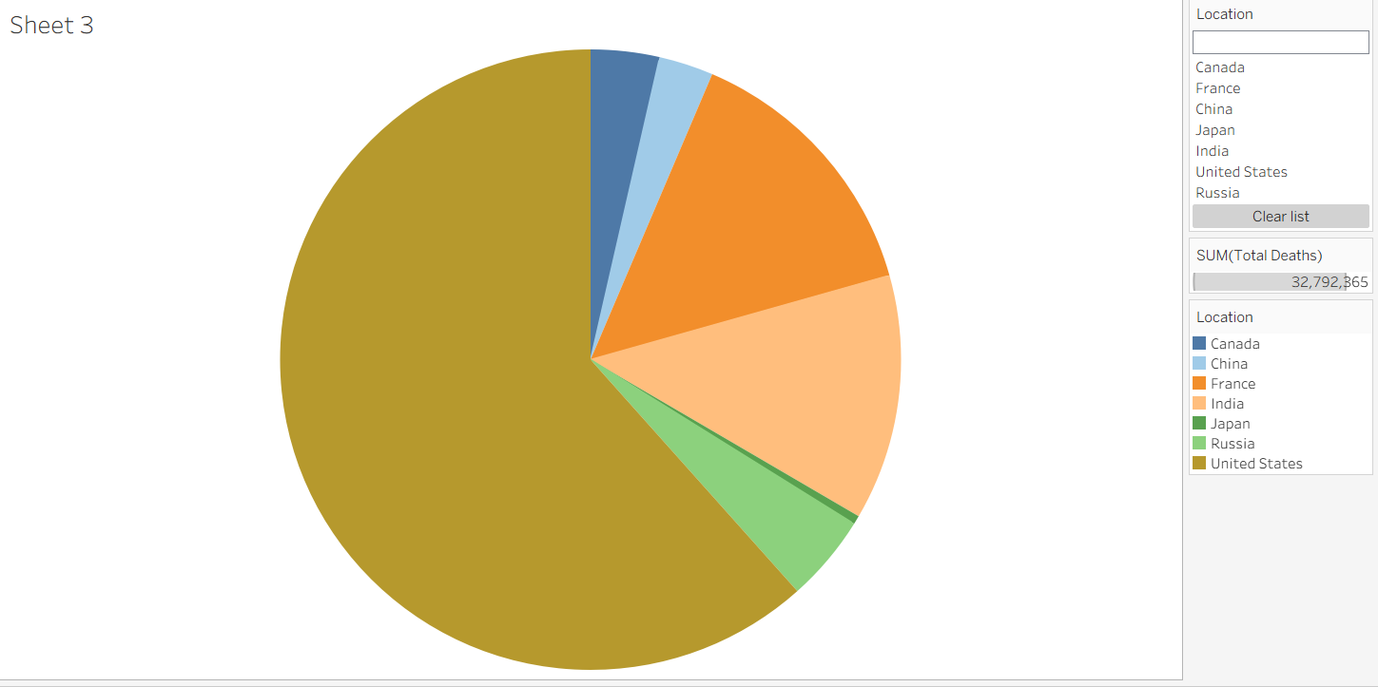

- Map (Filled Map) :
